COMENIUS : 1st TRIP IN LATVIA, PREILI (31st Oct -7th Nov 2010)
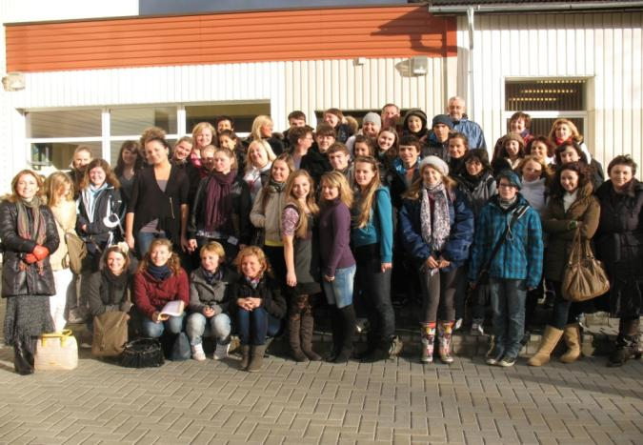

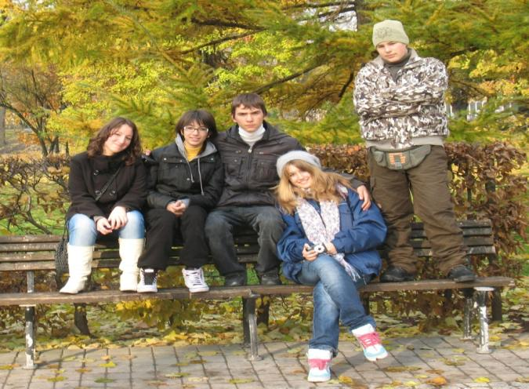

A few days ago , we came back from the 1st trip of Comenius School Partnership , which was in Latvia.
We are really happy and excited! We had a great time there ; we met interesting people and we made friends . We saw unique places , we learnt new skills , some Latvian , Italian & German words , we practised communication skills in English , we “tasted” some new kinds of music , dance , food etc. Also, we presented our school , our place , our city , our country !!!!

We started our trip on Saturday 31st October .We met each other at the airport of Athens and we took the plane to Frankfurt ….
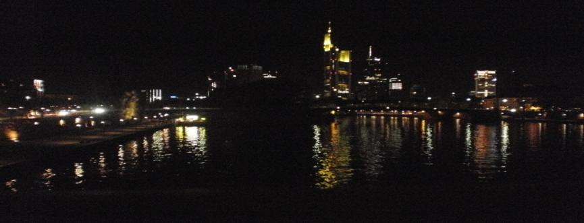
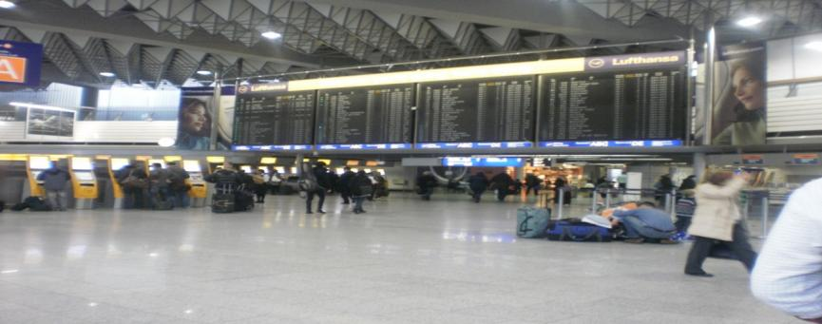
On Sunday afternoon we were in Riga !
On the 2nd day of the trip, we found our hotel and then we went for a walk around the city of Riga.. . When we went back to the hotel, a surprise waited for us. .
. .The Germans and the Scottish were waiting for us to go all together for dinner at a restaurant ! ! !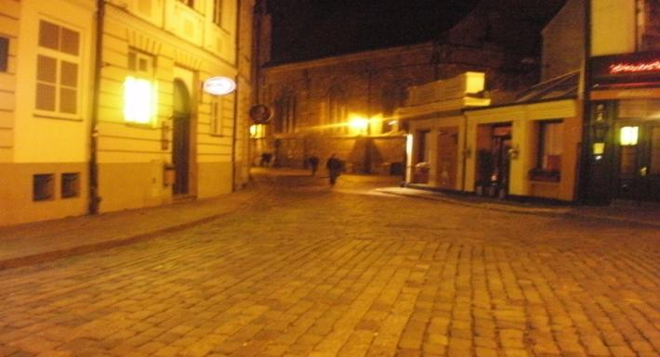

The 3rd day was special because we took a boat and we sailed across the river...and then we went sightseeing all over the city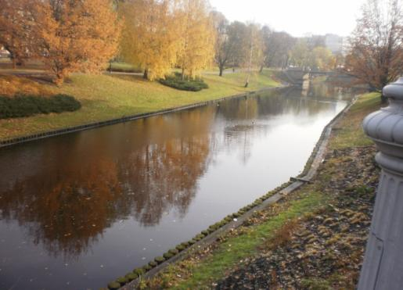 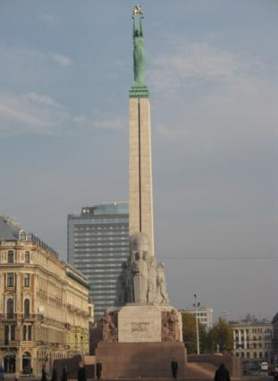

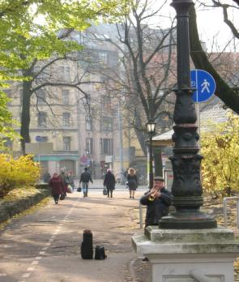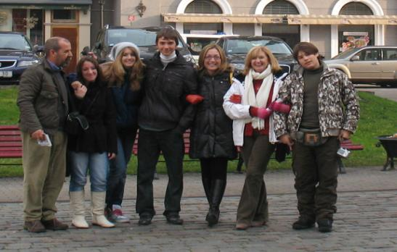
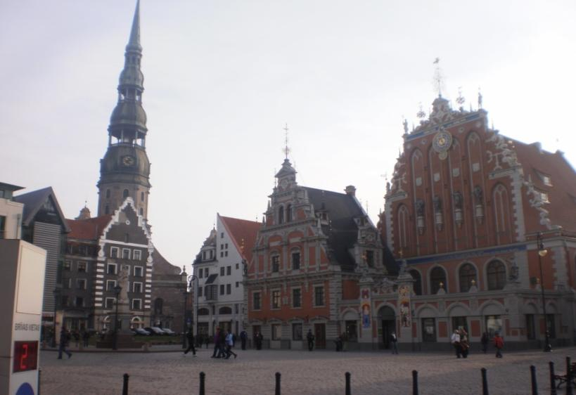
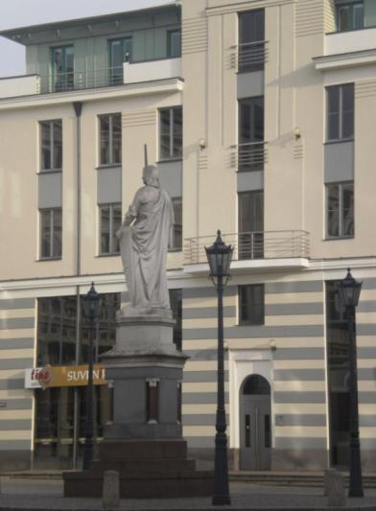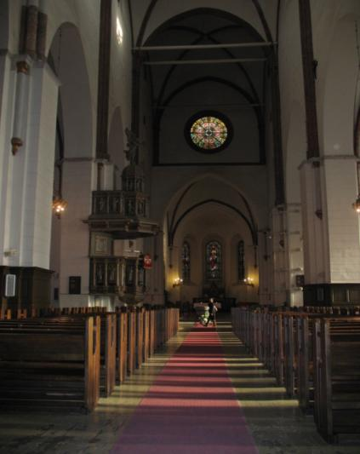

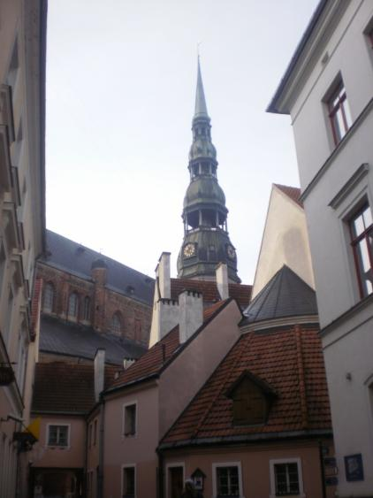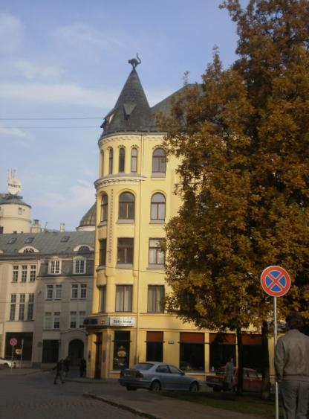

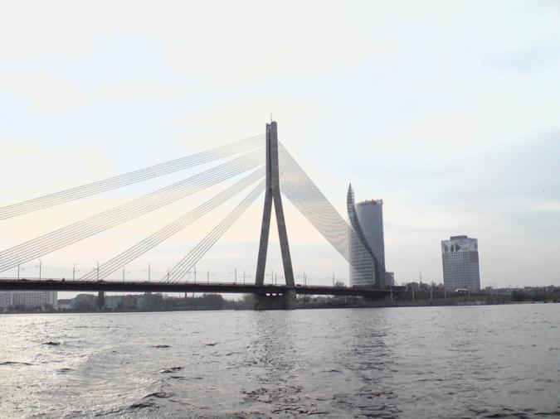
In the evening we went out for dinner all together again . We got to know each other a little bit more. .
It was the last night in Riga , because on the 4th day, early in the morning ,we set out for Preili , the final and the basic destination of the trip . . !
But, before leaving Riga we visited a wonderful forest .
It was an Open Air Museum showing how life was some centuries ago …
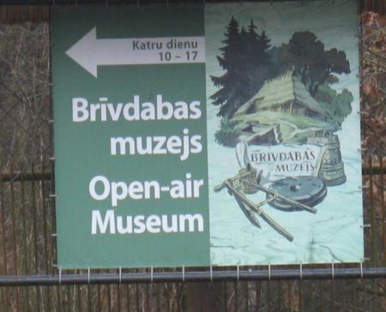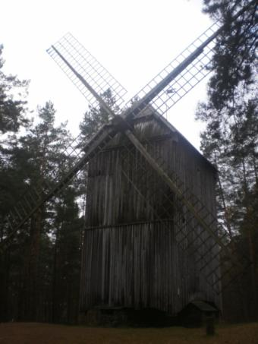
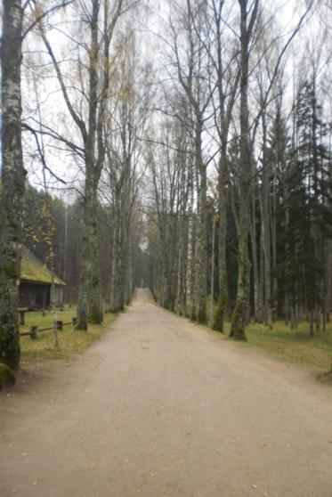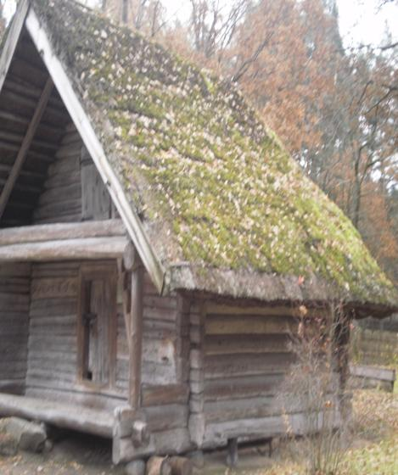
We finally started the trip to Preili! We arrived there late at night and we went straight to the house of 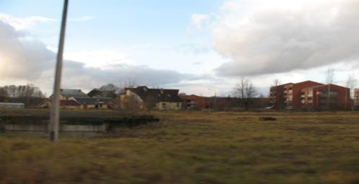
our host families. We would stay with them for the next 4 days … We met our “family” and we talked about ourselves and life in Greece, and we also
listened to them talking about life there…

On the first day, at school, we showed our presentation and we saw the presentations of the other countries. We saw folk Latvian dances and listened to traditional songs.
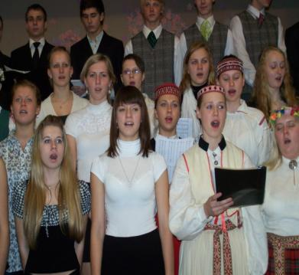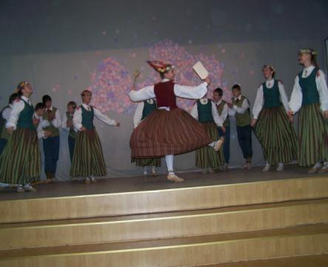

At the Town hall we met the mayor of Preili who talked to us about the history of the town.
We also visited a local museum about local history , a school of Arts (where we painted on
glasses and made bookmarks) and last , a chapel where we were told local ghost stories.
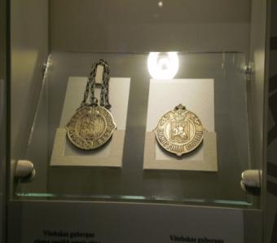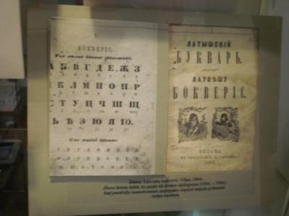
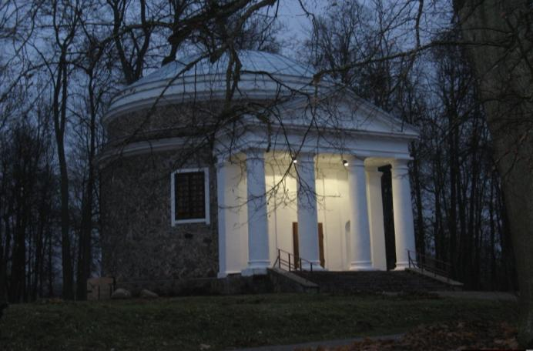

The next day, we visited the workplace of a man dealing with pottery and we learnt the local tradition over pottery. We also visited another town , called “Ludza”, and there we visited the workplace of some people dealing with weaving.
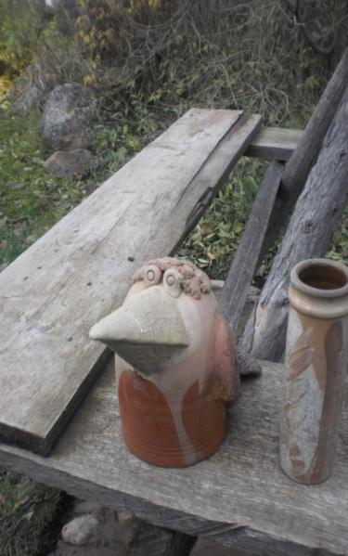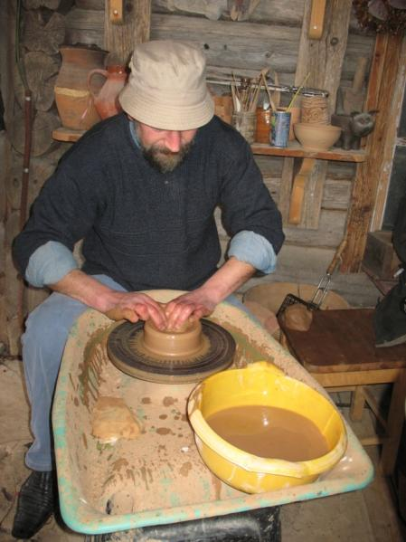

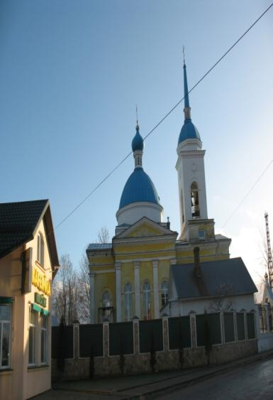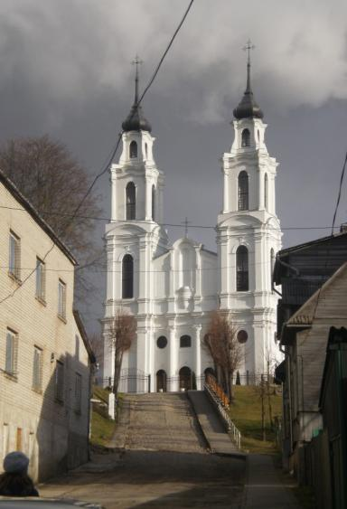

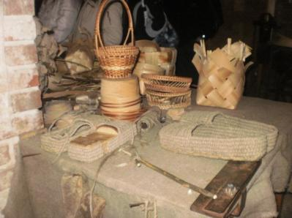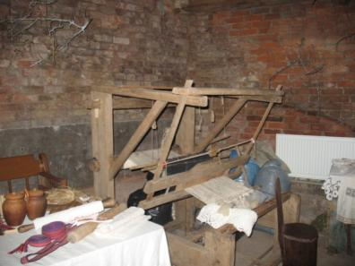

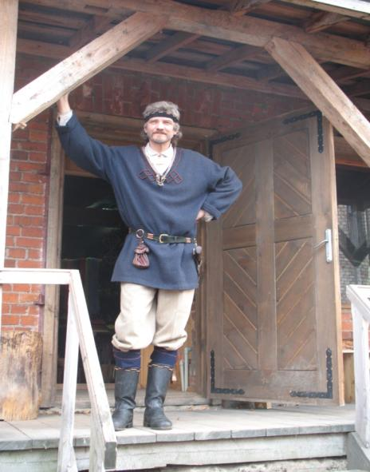

The last day we visited the library of Preili and the Doll Museum . There we had great fun because we wore the costumes of the dolls and were dressed like princesses and princes.We took a lot of photos… !
At school there was a farewell party where we danced local folk dances.
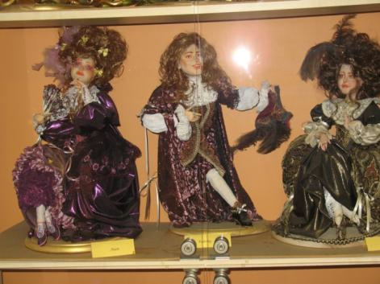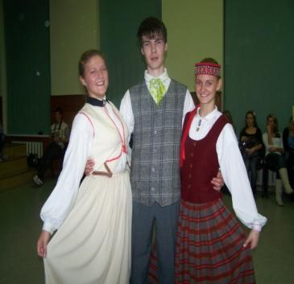

The next morning we said goodbye to the family that hosted us , to all our new Latvian friends and set off for Riga to catch our flight to Frankfurt. The Italians and Scottish were going to stay one more night in Riga. 6 hours later we were flying to Athens .
It was a trip we will never forget!!!
