ABOUT OUR SCHOOL

The name of my school is The Indian Heights School. It is situated in Dwarka, New Delhi. Apporx. 800 students from class Kindergarten to class X studies in my school. I love my school very much. It is a beautiful building. We have so many sports that is football, table tennis, cricket, basketball, lawn tennis, Martial Arts, yoga, and skating. I like all the teachers. I study English, Maths, S.Study, Science and Hindi subjects in my class.
......................................................................................................
Hello,
My name is …….. I will share with you the names of festivals we celebrate around the year.
OUR FESTIVALS
India is has diverse culture and people of many religions, cast and creed live here. Indian is also a country of festivals. People of different religion celebrate their functions and festivals. This makes India a very colourful country. We have different seasons i.e Summer, spring, rainy, autumn and winter. Every season brings festivals with them. Summers are very very hot and winters are now very cold. Rains are very heavy every season has its own charm. Our festival starts with the month of January, LOHRI, MAKAR SAKRANTI, in February Month we have BASANT PANCHAMI, ID-UL MILAD and MAHA SHIVRATRI in March month the festival of colours HOLI is celebrated in April month BAISAKHI, MAHAVIR JAYANTI, GOOD FRIDAY, AMBEDKAR JAYANTI is celebrated. In the month of May BUDDHA PURNIMA is celebrated. In the month of August We have RAKSHABANDHAN CELEBRATIONS, JANAMASHTAMI ID-UL-FITR and Our country’s INDEPENDENCE DAY. In the month of September we celebrate Ganesh Chaturthi. In the month of October we celebrated birthday of our Father of the Nationa
Gandhiji’s birthday on OCTOER 2 it is called GANDHIJAYANTI and we also celebrate DUSSEHRA and Valmiki JAYANTI and in the month of November we celebrated DIWALI and in the month of December we celebrate CHRISTMAS .

HI,
My name is ……. and I will tell you how we celebrate Diwali.
Diwali popularly known as Deepawali is a festival of lights and is primarily a five day Hindu Festival. Diwali falls between mid October or November. Diwali is an official in India. It is also the most important festival for Hindus.
Diwali is celebrated by lighting diyas(earthern lamps) made of clay with oil poured in them to signify the winning of good over evil. Homes are cleaned and decorated to welcome the goddess Laxmi (Goddess of money) people wear new clothes and distribute gifts and sweets to their relatives and friends. Crackers are burned because it is believed that it signifies the death of demons. Rangoli designed are made with colours and flowers. Outside the houses. The mornings are spent by decorating the houses and making Rangoli as shown in the picture below.

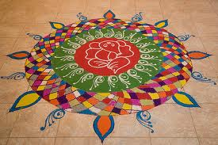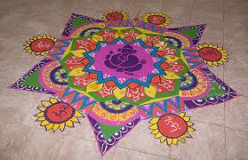
Making home made traditional food and sweets. In the evening worship the goddess Laxmi, the goddess of wealth and prosperity and them finally all bur crackers.

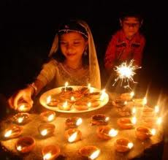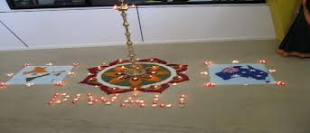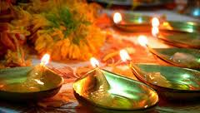The story behind Diwali goes a long time back when Lord Rama was sent on exile with wife Sita and brother Laxaman from Ayodhya (his kingdom) for 14 years. When Lord Rama came back from his exile, people of Ayodhya lit diyas to wlecome him and from that day Diwali is celebrated.

Hello,
My name is …... I wil tell you some places of interest in New Delhi. We live in a city and New Delhi is the Capital City of India.

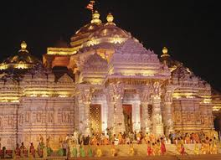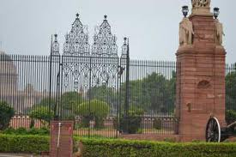
AKSHARDHAM TEMPLE
PRESIDENT HOUSE

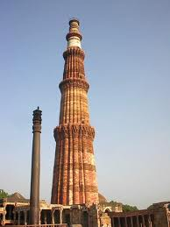
QUTUB MINAR
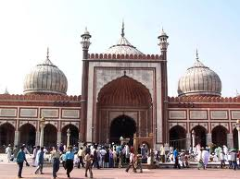
JAMA MASJID

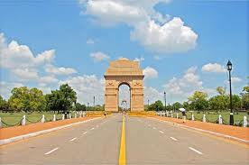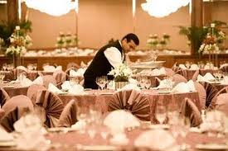
INDIA GATE
5 STAR HOTEL HILTON

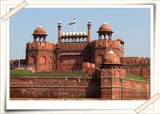
RED FORT

